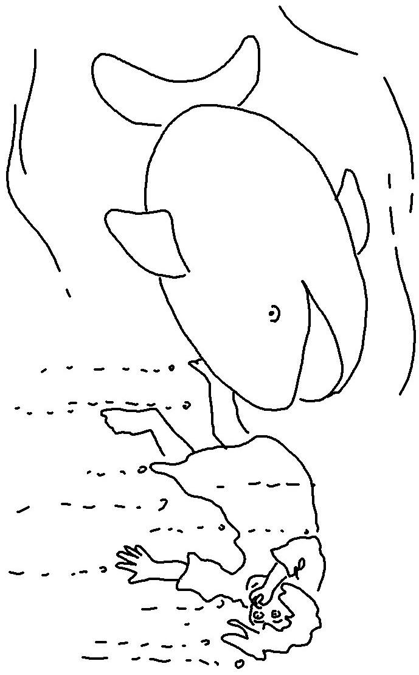

The Lord is slow to anger and filled with unfailing love.Numbers 14:18_{NLT}

